Do you feel anxious or stressed? Many of us find ourselves worrying often, feeling stressed or even getting stuck trying to pick out just one of our crazy thoughts to focus on. After reading this you will understand a strategy for calming your mind, body and find some peace. This strategy stimulates your vagus nerve through the use of mindful, purposeful breathing. The key to managing your mind state and your anxiety levels lies in being able to activate the calming nervous pathways of your parasympathetic nervous system.
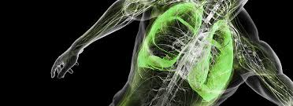
Breathing is crucial for our survival. Humans can survive typically three weeks without food, three days without water, and about 3-5 minutes without breathing. In many cultures, breathing is considered the vital link to maintaining energy, awareness, and composure.
When you encounter a perceived threat, such as a big test coming up, a fight between your family members, or a huge dog barking at you on the street, your hypothalamus (a tiny structure located at the base of your brain) sets off an alarm system in your body. This system causes the release of stress hormones (chemical messengers) including adrenaline and cortisol.
Adrenaline increases your heart rate, elevates your blood pressure and boosts energy supplies. Cortisol, the primary stress hormone, increases sugars (glucose) in the bloodstream, enhances your brain's use of glucose so you can think more clearly and increases the availability of substances that repair tissues. This complex natural alarm system also communicates with structures of your brain that control mood, motivation and fear.
Acetylcholine, another hormone, is responsible for learning and memory. It also helps you to become calm and relaxed. It is used by vagus nerve to send messages of peace and relaxation throughout your body. New research has found that acetylcholine reduces inflammation in the body. In other words, stimulating your vagus nerve sends acetylcholine throughout your body, not only relaxing you but also turning down the fires of inflammation which are related to the negative effects from stress.
Your body's levels of stress hormones are regulated by the autonomic nervous system. The autonomic nervous system has two components that balance each other, the sympathetic nervous system and the parasympathetic nervous system. The sympathetic nervous system “turns up” your nervous system. It helps us handle what we perceive to be emergencies and is in charge of the flight-or-fight response. The parasympathetic nervous system “turns down” the nervous system and helps us to be calm. It promotes relaxation, rest, sleep, and drowsiness by slowing our heart rate, slowing our breathing, constricts the pupils of our eyes, increases the production of saliva in our mouth, and so forth.
The vagus nerve is a cranial nerve, meaning it comes from the brain. It controls the parasympathetic nervous system, which controls your relaxation response. This part of the nervous system uses the hormone, acetylcholine. If your brain cannot communicate with your diaphragm by the release of acetylcholine from the stimulation of the vagus nerve then you will stop breathing and die.
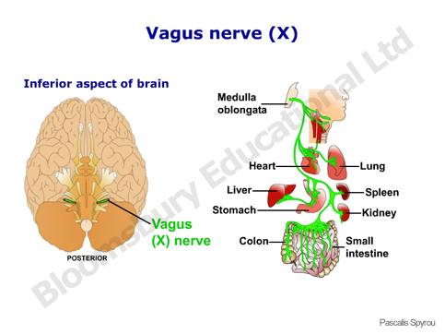
When the diaphragm contracts, your lungs expand, and air is pushed into your mouth and lungs. When you breathe from your abdomen, your belly will expand and move out with each inhalation. Your chest will rise slightly. Doing abdominal breathing activates the vagus nerve and triggers a relaxation response. The relaxation response, which is the opposite of the stress response, is necessary for your body to heal, repair, and renew.
The vagus nerve is the most important element of the parasympathetic nervous system (calming/relaxing). It originates from the brainstem and it is travels or wanders all the way down, into the belly, spreading neurons to the tongue, pharynx, vocal chords, lungs, heart, stomach, intestines and glands that produce anti-stress enzymes and hormones (like Acetylcholine, Prolactin, Vasopressin, Oxytocin), influencing digestion, metabolism and of course the relaxation response.
The vagus nerve acts as the mind-body connection, and it is the cabling behind your heart’s emotions and gut instincts.

Research from Japan shows that during relaxed abdominal breathing, brain activity (seen as waves) shows a pattern of relaxation. Poor heart rate variability (HRV) has been linked with increased mortality after heart attack, and has also been shown to be linked with depression, anger, and anxiety. Research has found that proper breathing, or purposeful and mindful breathing expands your diaphragm, stimulates your vagus system and instantly turns on the parasympathetic nervous system, causing your cortisol levels to reduce. The oxygen supply to your body's cells increases and this helps produce endorphins, the body's feel-good hormones. It also improves memory, fights depression, lowers blood pressure and heart rate and brings balance to the immune system.
How to Activate the Vagus Nerve using breathing…
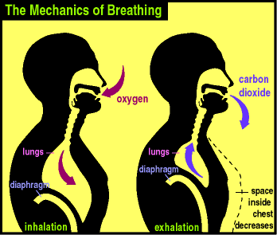
To practice deep breathing, inhale through your nose and exhale through your mouth. As you inhale through your nose count to four, pause for four seconds, then exhale out your mouth counting to four. Pause and count to four before you inhale again, through the nose and counting to four. Exhaling through your mouth instead of nose makes your breathing a conscious process (somatic nervous system), not a subconscious one (autonomic nervous system). Think about the breathing. Focus on counting to four, inhaling and exhaling. It is liberating when you can finally focus on one thing, and only one thing. While at rest most people take about 10 to 14 breaths per minute. Ideally, reduce your breathing to 5 to 7 times per minute.

