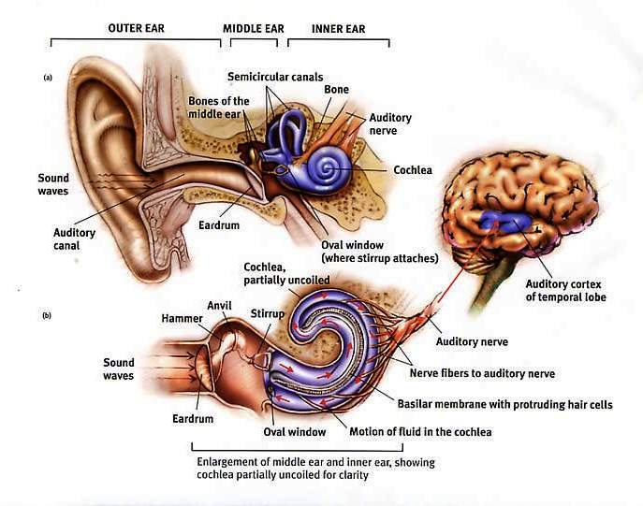

Balance
Balance requires the interaction between many different organs and systems in the body. The brain is the central processing center for all balance information coming from the senses and for all information going out to the muscles of balance. Input comes from three main areas: vision, the balance portion of the inner ear, and the touch (from the feet and joints). Vision is an important cue to the brain which tells us if we are moving relative to our surroundings.
There are two parts of hearing: mechanical and nerve (or electric). The mechanical part of hearing picks up sound from the outer ear canal and then vibrates the ear drum and the three tiny hearing bones in the middle ear. The inner ear looks a bit like a snail. It has two halves which are connected and are filled with fluid. The coil or cochlea takes care of the nerve part of hearing. Like a telephone it takes the vibration and turns it into an electric signal that is then relayed to the brain along a network of interconnected nerve cells.
The other half of the inner ear is the balance system or vestibular system. There are three balance canals, each set in different directions that respond to rotational movement of the head. Depending on which way you turn fluid, called end lymph, move within the canals and send the direction of the movement to the brain by way of the vestibular nerve. The inner ear fluid undergoes a natural recycling every day. It is made from the brain’s spinal fluid.

