Leaf disc photosynthesis Lab
Introduction
There would be no biology without photosynthesis by plants, algae and plankton. These amazing organisms are capable of capturing the energy of sunlight and creating Oxygen and glucose. They're literally capturing energy from outer space, and we're entirely dependent on them for every breath we take. We need organisms that undergo photosynthesis to survive. Interconnectedness. In this lab you will investigate how changing light (a reactant) changes the product.

Materials
Paper punch or straw to make leaf discs
Beaker 1. Baking soda (NaHCO₃) solution with 20 g NaHCO₃/L water
Beaker 2. Plain water
Beaker 3. Waste
Spinach leaves soaked in water overnight (grab 3)
Syringe (20mL or 60mL)
1 paper towel
1 straw
Phone for keeping time

Data table

# of discs used | Light source | Time of day | # of discs floating after 2 min | # of discs floating after 4 min | # of discs floating after 6 min | Time for all discs to float

Procedure
- Make data table in notebooks. Each person does this.
- Get all materials. Carefully please
- Punch out 10- 20 discs from spinach leaves using straw (the more the better). Record number on data table.
- Add discs to syringe using tweezers. Push them down to the bottom by tapping, blowing or nudging.
- Add plunger and push nearly to the bottom.
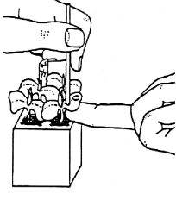
- Suck up 10 ml of baking soda solution if you have a 20 ml syringe. Suck up 30 ml if you have a 60 ml syringe.
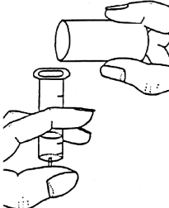
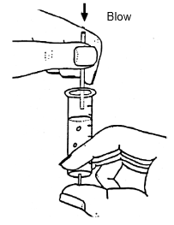

- Lift up on syringe to pull air out of syringe. Keep finger on tip end and suck out as much air from the syringe as possible. You need to pull all the air out of the discs. Push down to force solution into discs and pull up to get air out of the syringe. Discs will eventually fall to the bottom.
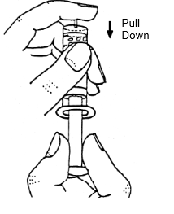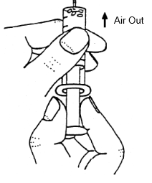
- Once discs are at bottom push out baking soda solution into beaker.
- Soak up 10 ml of plain water if you have a 20 ml syringe. Suck up 30 ml if you have a 60 ml syringe.
- Put syringe in your choice of light. Record light source.
- Record the number of discs that have floated to the top after 2 minutes.
- Record the number of discs that have floated to the top after 4 minutes.
- Record the number of discs that have floated to the top after 6 minutes.
- Record time that it took for all leaf discs to float.
- Answer questions found below in your notebooks. Write in complete sentences. Write question and answer.
- Clean up and put materials how you found them.
Follow up questions
- What is the source of water for the plants?
- What is the source of Carbon for the plants?
- What is the source of light for the plants?
- What went wrong during this lab for you?
- Why do we need the baking soda?
- Why do the leaf discs become buoyant after light exposure?
- What would happen if you put the syringe into the cabinet instead of under a light source?
- What do you think are the reactants and products of photosynthesis?
- Calculate the rate of photosynthesis using the following format:

Number of leaf discs (#) = __________________ discs/seconds
Total Time (seconds)

- Critical reasoner: Use evidence from activity to design another experiment to measure reactants or products of photosynthesis.

