Name:
Period:
BIOLOGY STUDENT CONTRACT

Class:
Tutoring:
Website:
Contact info:

The following are the classroom policies and procedures. By signing this contract I am committing to following all of them for the school year of 2018-19. I am committing to sharing this information with someone at home so that they know exactly what is expected of me in biology.

Bathroom policy-

Emotions-

Headphones-

Phones-

Food/Gum-

Mindfulness-

Materials-

Talking during class-

Walking-

Code switching-

Science Portfolios- Track progress in science skills (LT 6)

Learning Targets-

Cheating policy-

AAA-

Absent Policy-

Late Policy-

Final on last day of school-

4.0 =
3.5 =
3.0 =
2.5 =
2.0 =
1.5 =
1.0 =

Grading policy-

State your needs-

Dear parent/guardians,

Hi my name is Bern Gross and I teach biology. Biology will focus on studying life, growing content knowledge and science skills. Students will be presenting at least one time during the year and we would love for you to come and be there. They will tell you their presentation date within the first two weeks so that hopefully you can come! Please keep the following information so that you can contact me if needed. Students were asked to share their contracts with you in detail. Please ask questions.

Si su lenguaje preferido es español, avíseme para que pueda traducir comunicaciones y correspondencias. Por favor firme esta página y devuélvela con su estudiante.

Bern Gross Biology Room 135
Email: Bern_gross@escsonline.org
If I do not respond to the email, I did not read it.
Tutoring: Tues/Wed 3:30-4 & by appointment
Class Website: http://grossbiology.weebly.com.
--------------------------------------------------------------------------------------------------------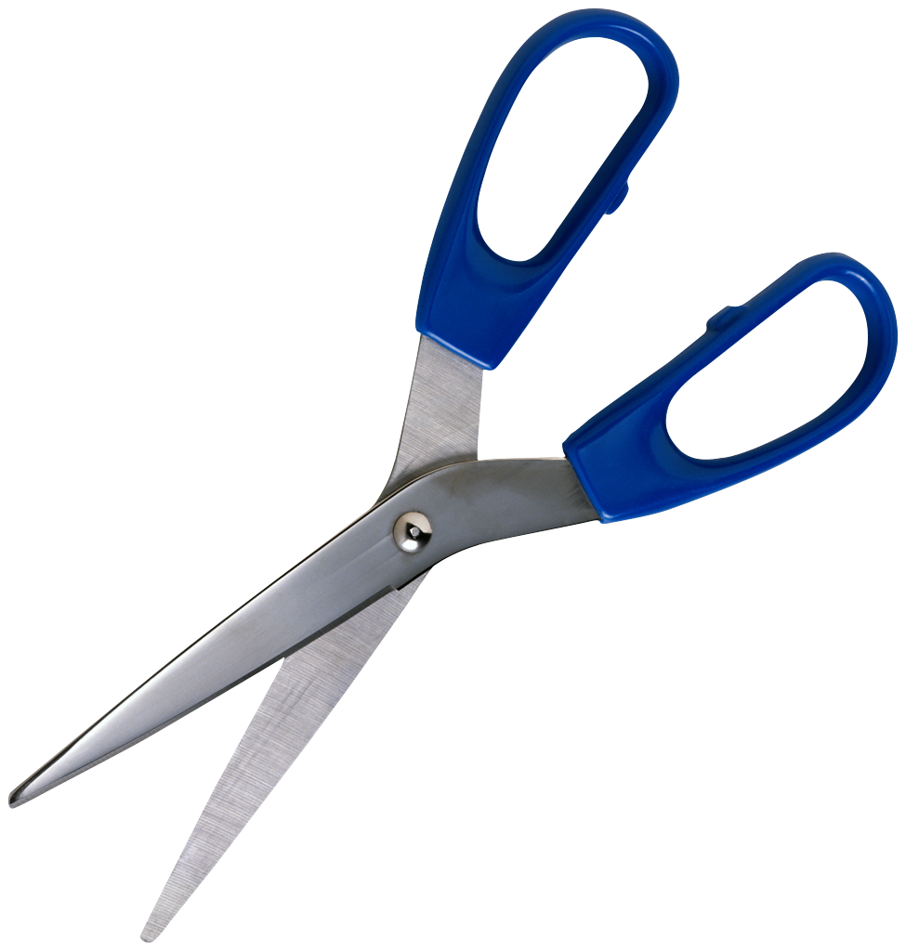

Student name: ________________________________ Class period for Biology: ___________

Adult name: __________________________________ Adult sign: _________________________________________

Please initial the following:

__________ My child went over the biology contract with me.

__________ I understand what is expected of them during the year.

Comments/concerns/requests:

What is the best way to contact you? Que es la mejor manera para contactarte?
Contact info:

